**SUPERMARKET MANAGEMENT SYSTEM**

1. Introduction :

**1.1 PURPOSE :**

The aim of this document is to specify complete description of the

Supermarket Management System to be developed. It is basis for agreement between suppliers and customers about the product to be developed. This document is going to describe functionality, external interfaces, performances, attributes and design constrains of the system.

**1.2 SCOPE :**

This system will provide the larger facilities to operating and managing the details of supermarket so that the usability for administrator or user become high. This project will satisfy the powerful requirements for larger Supermarkets and will provide the reliability for the user.

**1.3 OVERVIEW :**

We are going to focus on describing the system in terms of product perspective, product functions, user characteristics and assumptions. Next we will address specific requirements of the system such as performance requirements. There are two users in this system

* Administrator
* User

**1.4 Administrator :**

•  Admin person can add, edit and delete items

•  Admin person creates users of the system giving some authority not all.

•  Admin person controls daily sells and feedbacks from customers.

•  View the history of the customers who purchased the items.

•  The main role of the administrator is to safeguard the database and can add/delete the products from the database.

**2 External Interface Requirements :**

**2.1-HARDWARE REQUIREMENTS :**

|  |  |  |  |
| --- | --- | --- | --- |
| **Hardware requirements** | | | |
| **Item No** | **Item Name** | **Minimum** | **Maximum** |
| 1 | RAM | 2GB | 4GB |
| 2 | PROCESSOR | 2 GHz | 2.4 GHz |
| 1 | HARD DISK | 40 GB | 500 GB |

**2.2-SOFTWARE REQUIREMENTS :**

|  |  |  |
| --- | --- | --- |
| **Software requirements** | | |
| **Item No** | **Item Name** | **Version** |
| 1 | XAMPP | 1.0 |
| 2 | Google Chrome | **71.0.1578.98** |
| 1 | NOTEPAD ++ | 2.7 |

**3.MODULES DESCRIPTION**

3.1)SIGN IN :

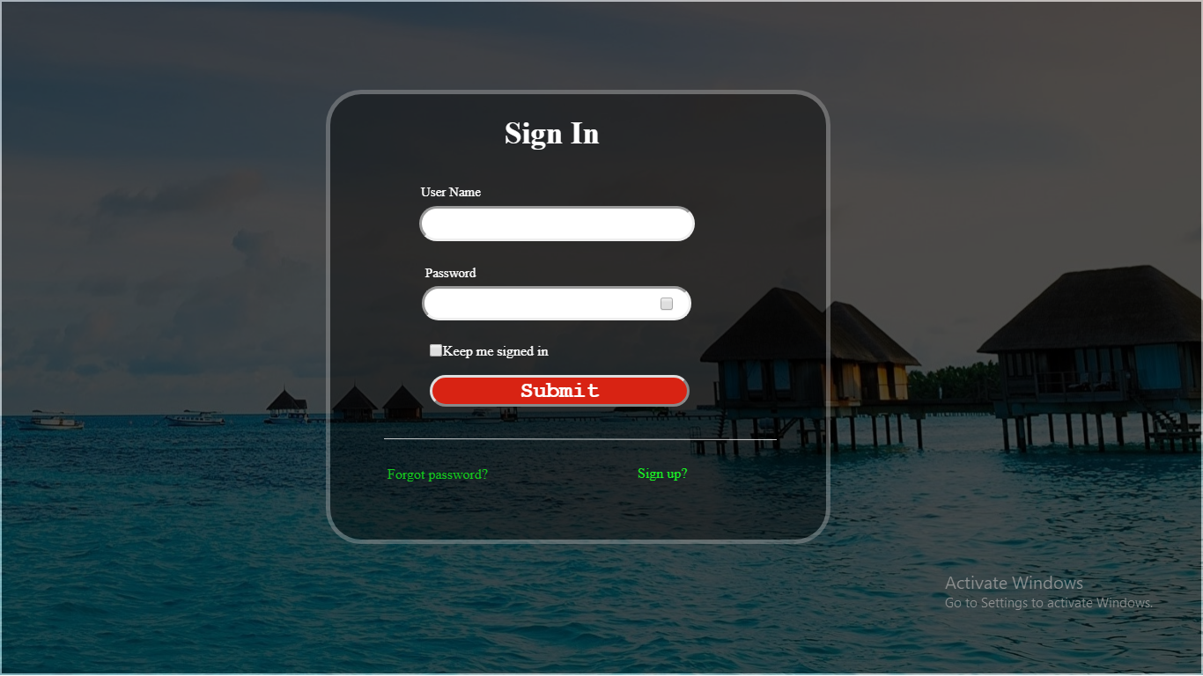

If any administrator wants to enter in the system , he/she has to give his/her username and password. If the given details matches with existing one it allows the admistrator. Else it shows an error.

3.2)SIGN UP :

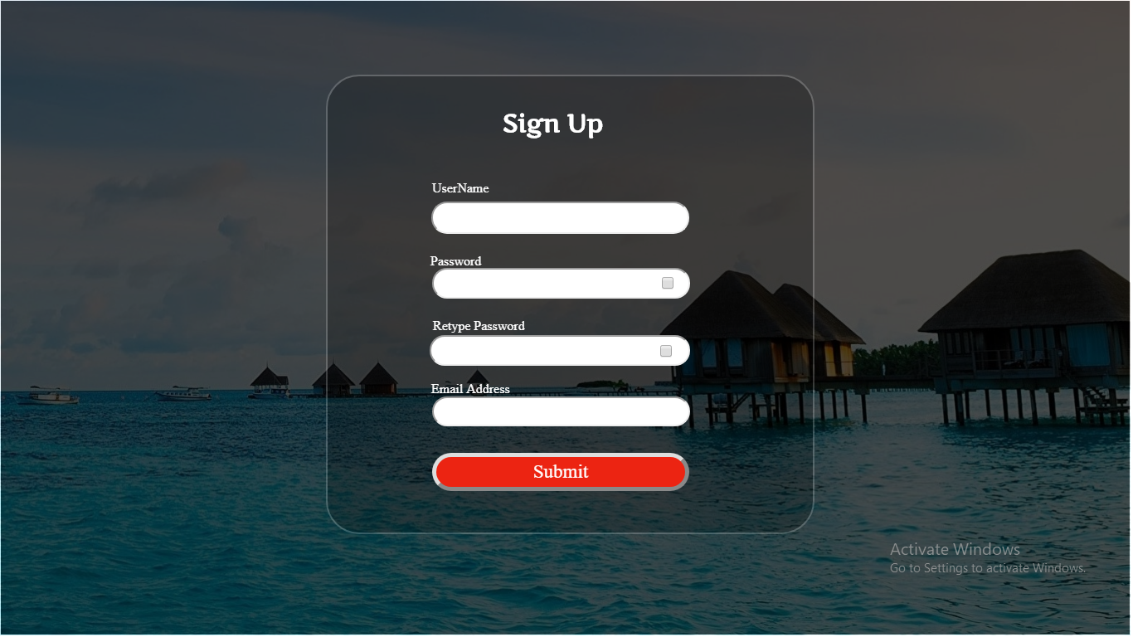

If the user is new to the system , he has to enter the required details and submit it.

3.1)SUPPLIER :

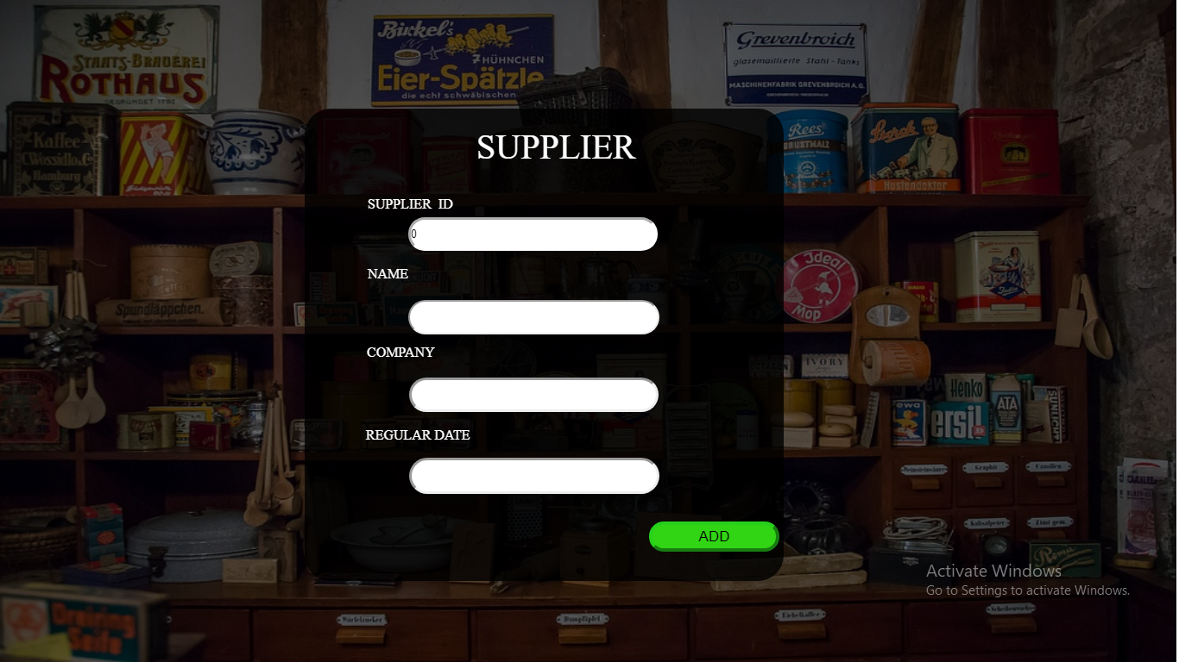

In this module , we can store the details of all the supplier And we can update the details.

3.4)INSERT PRODUct[STOCK] :

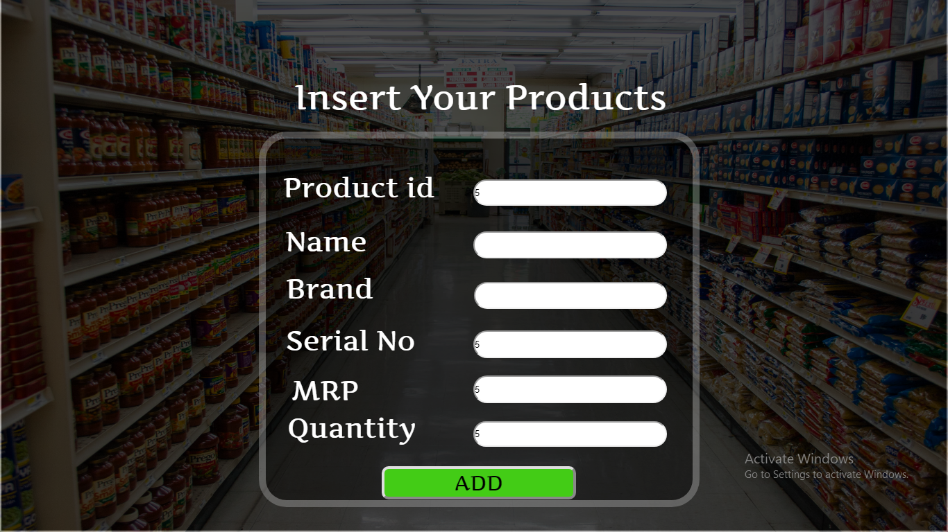

In this module , we are storing the details of every product . Instead of giving of id of every product , we can use a scanner to implement it. We can insert the new product or we can update the number of products that already exist.

3.5)WoRKER :

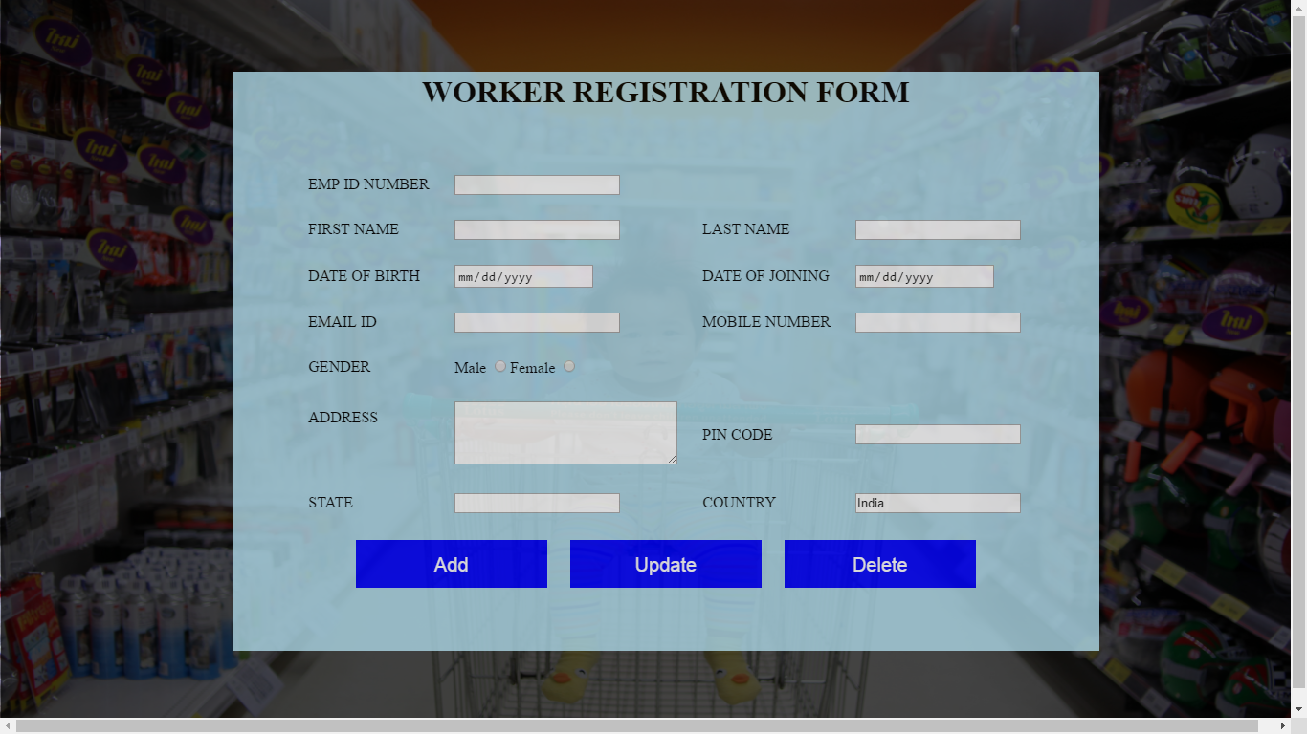

It gets the details of all workers and store it in the database . here we have 1 options called add , update and delete to their corresponding operations.

3.6)BILLING :

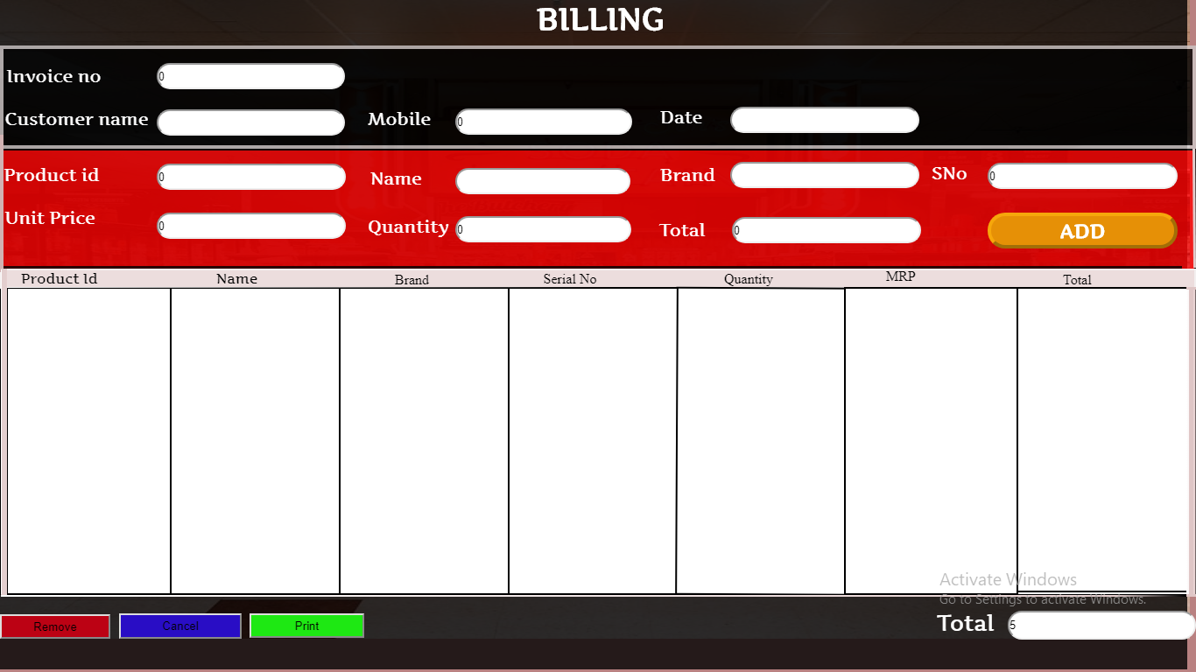

It gets the customer name and mobile number from the customer . While scanning the barcode of the products , it automatically fills the required fields and adds it to the invoice. We can see all the products which are bought and if we want to remove the item we have the option called remove. If there is any discount for the product it automatically calculate the amount . If we want to abort the process we can use the cancel option to do it.Finally the total price will be displayed and by clicking the print option we can print the invoice.